Contents

A. Heading and numbering 1
1. Section heading - Heading 2 (sentence case) 1
1.1. Section sub heading - Heading 3 1
B. Formatting 1
1.3. Images 1
1.4. Tables 1
1.5. Navigation 2
1.6. Prompts and reminders 2
1.7. Picking out key areas on images 2

Heading and numbering

If the above section divider is not used heading 2 becomes heading 1 and heading 3 becomes heading 2.

Section heading - Heading 2 (sentence case)

  - Section sub heading - Heading 3 (sentence case)

- Numbering level 1

  - Numbering level 2

    - Numbering level 3

Formatting

Font
Verdana is one of the fonts recommended for documents as it is easier to read.

Images
Screenshots are best taken with Snagit or the Snipping Tool as they are easier to work with and edit.

Tables
Useful for documenting how to update a list of data items or a screen with multiple items e.g. Creating or amending UDFs.

Column1 heading | Column2 heading

Example:
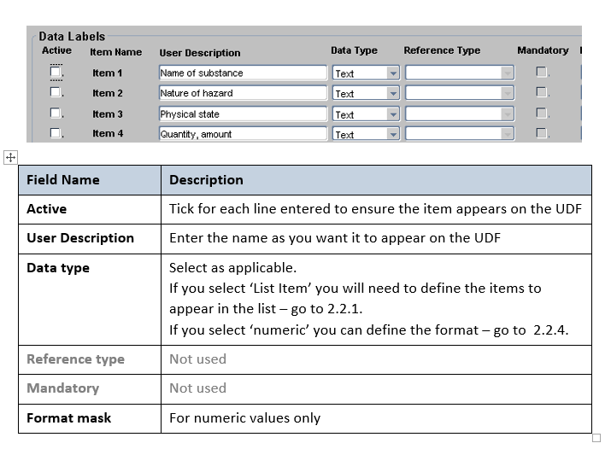

Navigation

Navigate to: enter > the > navigation > string > here

Prompts and reminders

 | NB: Things you must/must not do.

 | NB: Useful reminders and points to note/for info. The process won’t fail if you ignore this note.

Picking out key areas on images

Useful on busy screens or if item is not easily identifiable. Best done in Snag-it where possible as it is more flexible and the formatting is embedded into the image rather than sitting over the top.

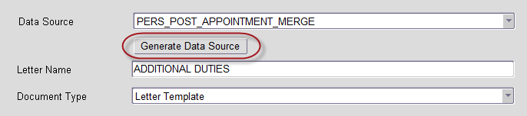

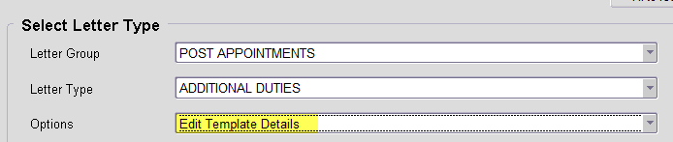

Knowledge Article: Add a link to the relevant knowledge article here

